IA#1 Web Programming

Zaid Burrell
Faculty of Engineering and Computing, University of Technology Jamaica
CIT2011: Web Programming
Professor: Sirisha Badhika
October 10, 2026

Figma Template Link: https://www.figma.com/design/k3Wn2pEKlHT2iBvVF9PnJz/-Zaid-Burrell---2505162--IA-1-Storyboard?node-id=0-1&t=80MlhACIFaCGNhjJ-1
Colour Palette: 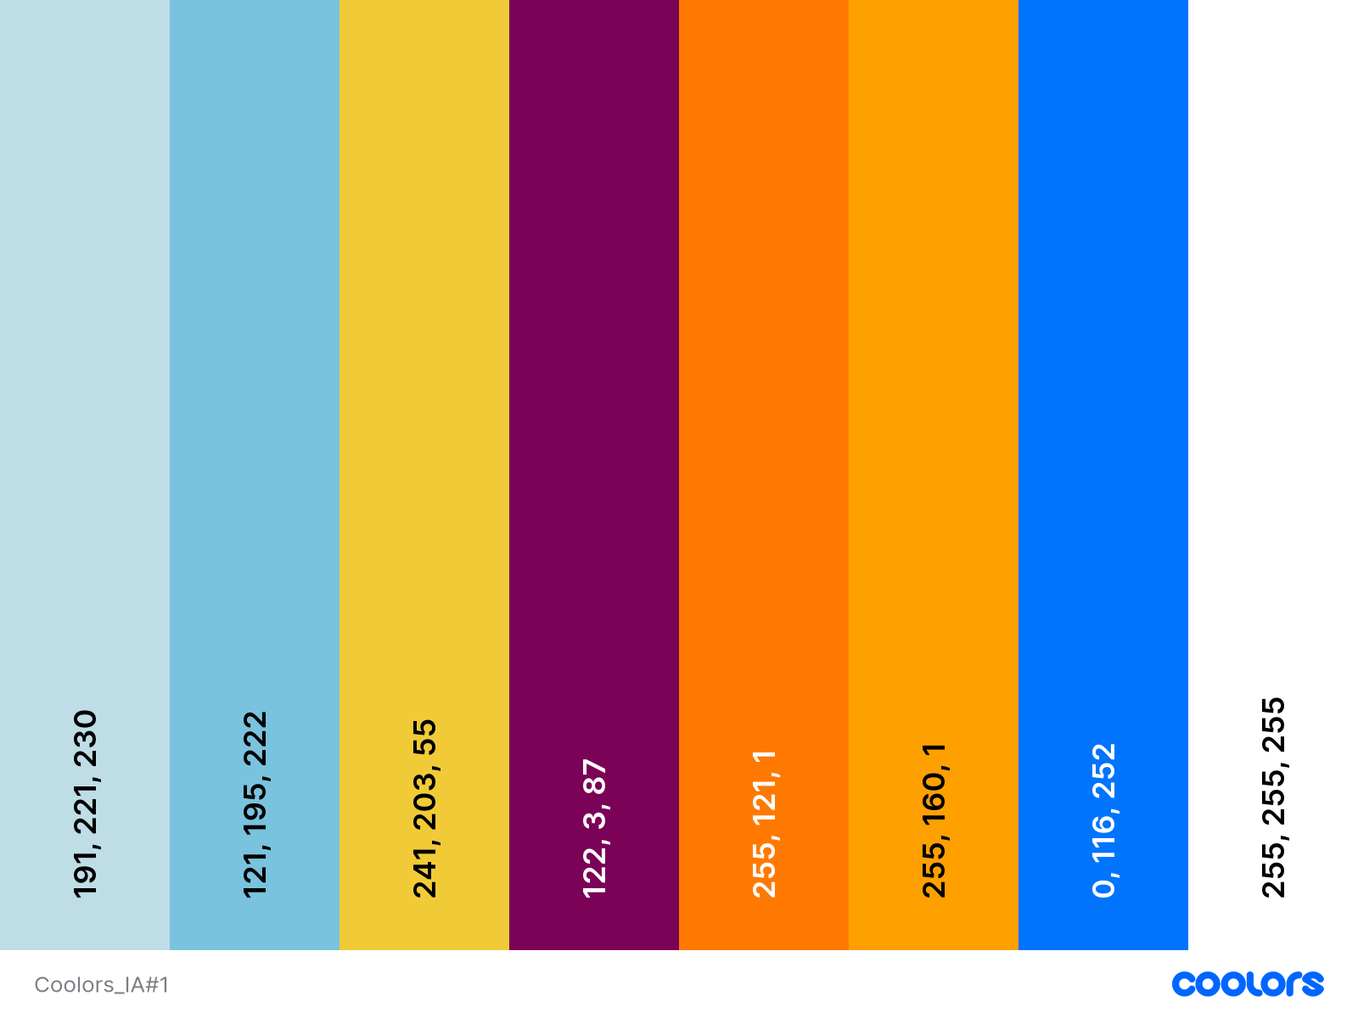

Icons and Dimensions:

70 x 70

70 x 70

70 x 70

70 x 70



500 x 714.275
400 x 400




283 x 217
100 x 100

Fonts used:
@font-face {
font-family: "OpenSans";
src: url("../Assets/Fonts/Open_Sans/OpenSans-VariableFont_wdth_wght.ttf")
format("truetype");
}
@font-face {
font-family: "PlayFair";
src: url("../Assets/Fonts/Playfair_Display/PlayfairDisplay-VariableFont_wght.ttf")
format("truetype");
}
@font-face {
font-family: "Cinzel";
src: url("../Assets/Fonts/Cinzel_Decorative/CinzelDecorative-Regular.ttf")
format("truetype");
}

Cinzel: https://fonts.google.com/specimen/Cinzel+Decorative?preview.text=Professional&preview.script=Latn&specimen.preview.text=Professional
Playfair: https://fonts.google.com/specimen/Cinzel+Decorative?preview.text=Professional&preview.script=Latn&specimen.preview.text=Professional
Open Sans:
https://fonts.google.com/specimen/Open+Sans?preview.text=Zaid&specimen.preview.text=Zaid&categoryFilters=Seasonal:%2FSeasonal%2FKwanzaa
Root font-weight: 500
Root font-size: 16px
Git-hub repository: https://github.com/WorkingZaid/zburrell_2505162_utech
Working Git-hub link (Working hosting link): https://workingzaid.github.io/zburrell_2505162_utech/

References
Harvard College Guide to creating a strong resume. Harvard FAS | Mignone Center for Career Success. (2026a, July 13). https://careerservices.fas.harvard.edu/resources/create-a-strong-resume/
Lehmann, M., Cornelius, P. B., & Sting, F. J. (2025, March 8). Ai meets the classroom: When do large language models harm learning?. arXiv.org. https://arxiv.org/abs/2409.09047
Augenstein, I., Baldwin, T., Cha, M., Chakraborty, T., Ciampaglia, G. L., Corney, D., DiResta, R., Ferrara, E., Hale, S., Halevy, A., Hovy, E., Ji, H., Menczer, F., Miguez, R., Nakov, P., Scheufele, D., Sharma, S., & Zagni, G. (2023, October 10). Factuality challenges in the era of large language models. arXiv.org. https://arxiv.org/abs/2310.05189
Goodman, R. B., Spicer, R. A., Feher, J., & Clason, G. S. (1974a). The richest man in Babylon. Island Heritage; Distributed by Island Heritage Ltd. (USA).

Validation Checks:
index.html – No errors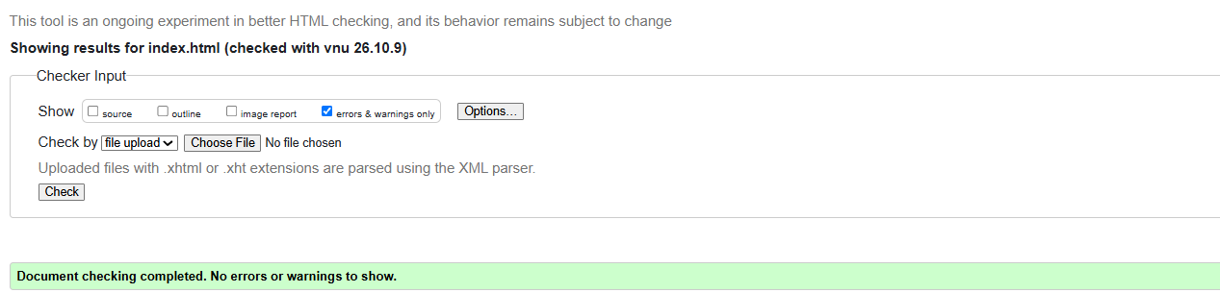
personal.html – No errors
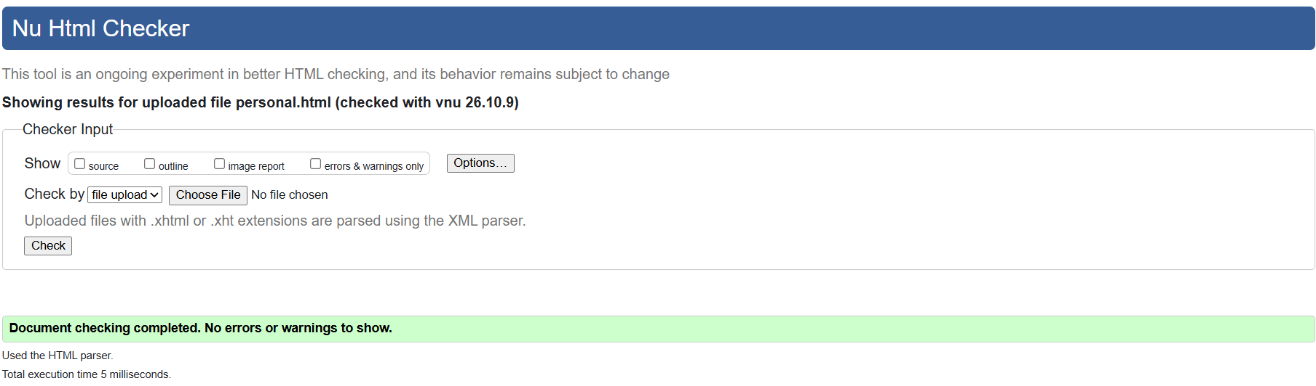
personality.html – No errors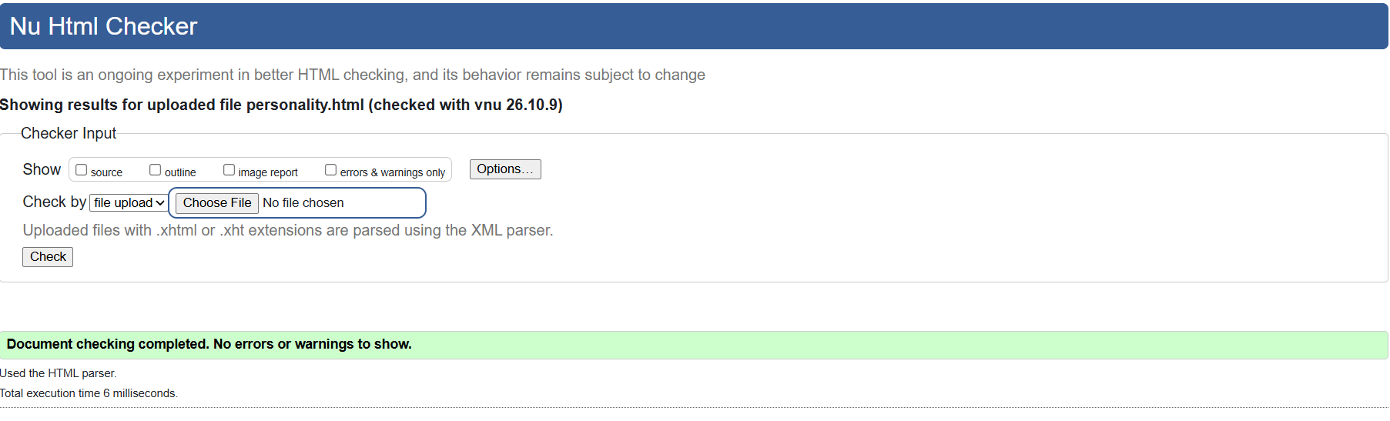 professional.html – No errors 